Micro Rider Pedal micro switch adjustment
For proper operation with foot off of the pedal switch is open, if switch is out of adjustment switch shows closed when pedal is in up position this causes error code. Loosen two screws and adjust switch to the right away from the pedal.
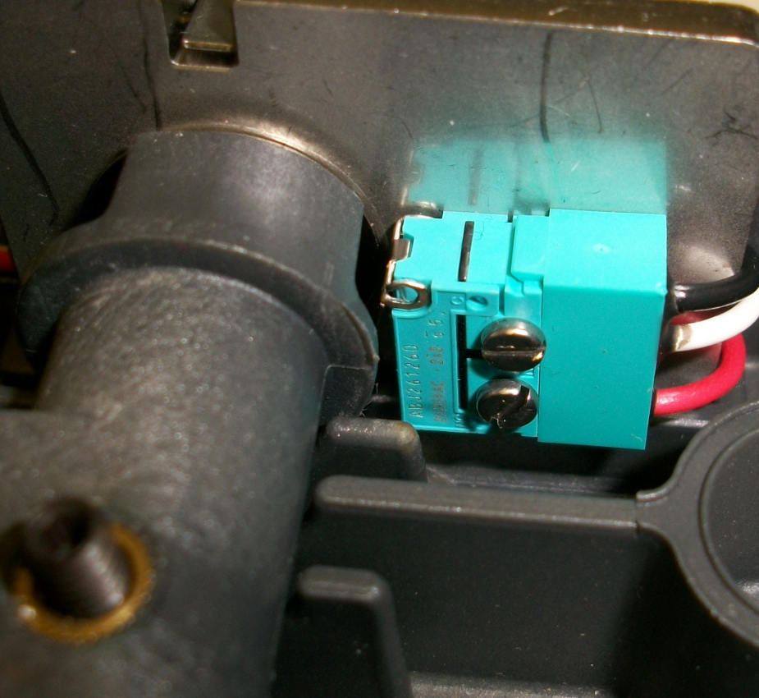

Pedal in up position, switch is adjusted and is open, infinite ohms

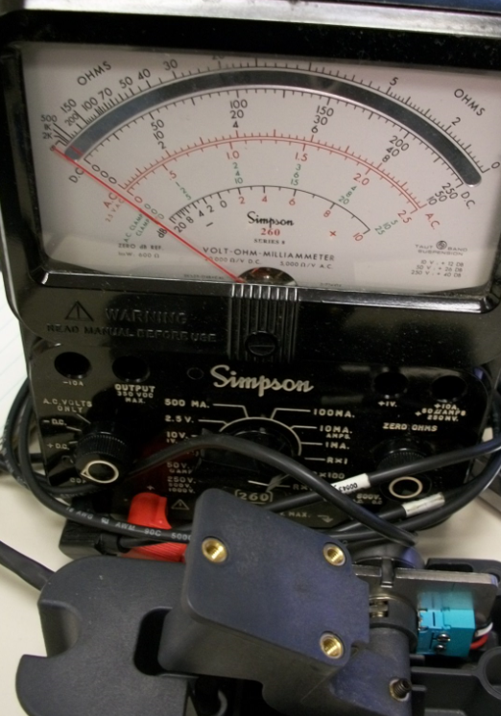

Pedal is depressed switch is closed zero ohms
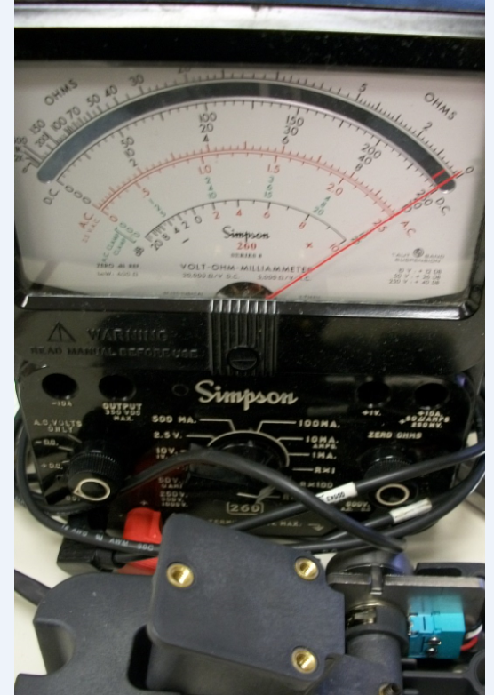

Connect ohm meter to these 2 pins on multi pin connector for the pedal. Note positioning of the locator keys

